## Project: Code Reviewer with Llama 3 LLM

### 1. Executive Summary

This report details the development of "Code Reviewer," a web application designed to assist developers in enhancing code quality using the power of the Llama 3 large language model (LLM). By seamlessly integrating code uploads, natural language queries, and advanced LLM analysis, Code Reviewer aims to automate and streamline the code review process.

Key Features:

* Supports code uploads in multiple programming languages (Python, Java, JavaScript).
* Allows developers to ask specific questions or provide context using natural language.
* Leverages Llama 3's 70B parameter model and expansive context window for comprehensive analysis.
* Provides clear, concise feedback and suggestions through an intuitive web interface.

### 2. Problem Statement

Code review is an essential practice in software development, ensuring code quality, maintainability, and adherence to best practices. However, traditional manual code reviews can be time-consuming, prone to human error, and often lack the depth of analysis provided by automated tools.

This project addresses the need for an intelligent code review solution that can:

* Automate the identification of potential issues: Such as bugs, security vulnerabilities, style inconsistencies, and areas for optimization.
* Provide actionable feedback and suggestions: Offering developers clear guidance on how to improve their code.
* Enhance developer productivity: By freeing up time spent on manual code review and reducing the likelihood of introducing defects.

### 3. Proposed Solution: Code Reviewer

Code Reviewer leverages the capabilities of the Llama 3 LLM, recognized for its exceptional code understanding and generation abilities. The application follows a structured workflow:

3.1 Code Upload and Preprocessing:

* Users upload their code files (.py, .java, .js).
* The application preprocesses the code, potentially performing syntax highlighting or basic static analysis.

3.2 Natural Language Input:

* Users can provide additional context or ask specific questions about their code using natural language (e.g., "Check for any potential SQL injection vulnerabilities").

3.3 LLM-Powered Analysis:

* Code Reviewer utilizes LangChain, a framework for developing applications powered by language models.
* It employs AI21Embeddings to create meaningful representations of the code and user queries.
* These embeddings, along with the code itself, are used to query the Llama 3 model via the Groq API.
* A vector store (FAISS) efficiently stores and retrieves code chunks based on semantic similarity, enabling context-aware responses from Llama 3.

3.4 Review Output:

* Code Reviewer presents the LLM-generated review in a user-friendly format using Streamlit's web interface.
* Review output includes:
  + Summary of findings: Highlighting key issues and areas for improvement.
  + Detailed explanations: Providing insights into potential problems and suggested solutions.
  + Code snippets: Illustrating problematic areas and proposed fixes.

3.5 Technology Stack:

|  |  |
| --- | --- |
| **Component** | **Description** |
| User Interface | Streamlit |
| LLM Interaction | LangChain |
| Language Model | Llama 3 (70B) |
| Embeddings | AI21Embeddings |
| Vector Store | FAISS |
| API | Groq (for Llama 3 access) |
| Programming Languages | Python, JavaScript (for Streamlit), Python (backend) |

### 4. Project Implementation (Refer to app.py and helper.py)

This section provides a technical walkthrough of the codebase (refer to the provided files).

Key Implementation Details:

* app.py: Handles the web application logic using Streamlit:
  + Uploads code files.
  + Collects user input (optional questions/context).
  + Invokes LLM functionality through the ResponseLLM class.
  + Renders the review output.
* helper.py: Encapsulates the core LLM interactions:
  + Loads and preprocesses text data.
  + Creates and manages the FAISS vector store.
  + Defines the prompt template for Llama 3.
  + Executes the LLM query and returns the response.

Code Snippets:

* Loading and splitting text (from helper.py):

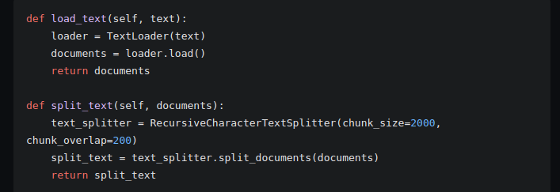

* LLM Response Generation (from helper.py):

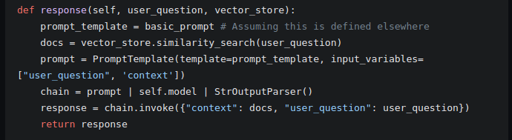

### 5. Project Evaluation

* Qualitative Evaluation:
  + Assess the clarity, relevance, and helpfulness of the LLM-generated code reviews.
  + Gather feedback from developers on the overall user experience and the value of the tool.
* Future Enhancements:
  + Expand Language Support: Integrate support for additional programming languages.
  + Code Repository Integration: Allow users to directly analyze code from platforms like GitHub.
  + Enhanced Visualizations: Incorporate code visualizations to highlight problematic areas.
  + User Customization: Enable users to customize review criteria and feedback preferences.
  + Performance Optimization: Explore techniques to improve the speed and efficiency of code analysis.

### 6. Conclusion

Code Reviewer offers a promising solution to automate and enhance the code review process, enabling developers to write higher-quality, more maintainable, and more secure software. By leveraging the remarkable capabilities of the Llama 3 LLM, this project aims to significantly impact developer productivity and overall software quality.